**Home** About Us Team Updates Contact Us

SASCAN Early detection Saves lives!! /Reaching out to Millions

Home

(Flash of images with text)

*Image 1.*

Image of rural India (men)

Text: Oral Cancer is the 8th largest prevalent cancer, over half of the diagnosed die in the same year. (source to be mentioned, if required)

*Image 2.*

Image of rural India (women):

Text: Cervical Cancer is the 2nd largest prevalent cancer in women, with disease burden of over 1.5 million around the world.

*Image 3.*

Image of a healthcare worker

Text: Bringing affordable cancer screening to the doorstep of masses.

*Image 4.*

Image: Coming soon

Text: Hand held device, easy to use, Real time results (in bullets)

In the bottom of the pages, there will be logo of NOVARTIS AWARD OF ICMR, BIRAC, BIG, IKP, and MILLENIUM ALLIANCE.

Visit us at SURGE (give the logo), Bengaluru, India Feb 23-24, 2016

On right hand bottom, Stay in the loop: email: ……………(SUBMIT)

Home **About Sascan** Team Updates Contact us

SASCAN Early detection Saves lives!!

About Sascan

Sascan Meditech is an emerging healthcare innovation company founded by a diverse and experienced team of scientists, clinicians, global health experts, design thinkers, engineers and business developers who are passionate about one common thing-'making a difference in the lives of people'.

We aim to achieve this by bringing affordable healthcare innovations for better medical outcomes at grass-root levels. Our mission is to **innovate** healthcare solutions that are **Affordable, Accessible, Available and Appropriate** for the masses, and **implement** them through **sustainable business models** to create **impact**.

Sascan's first product is an **intra-oral screening camera** for early detection of oral cancer. This non-invasive device is the first of its kind which will be able to give real time diagnosis of the lesions and can be easily operated by minimally trained personnel. We have received funding from the **Government of India under the Biotechnology Ignition Grant (BIG) scheme of BIRAC** for the development of this product.

Sascan is continually innovating new products to address the gaps in healthcare. Our proposal for development of a **novel cervical cancer screening device** has been short-listed for funding by the **Millennium Alliance**.

In the bottom of the pages, there will be logo of ICMR, BIRAC, BIG, IKP, and MILLENIUM ALLIANCE.

Home About Sascan **Team**  Updates Contact us

SASCAN Early detection Saves lives!!

TEAM

Dr Subhash Narayanan



Dr Subhash Narayanan is the Founder Director of Sascan Meditech. He is a PhD in Laser Physics from the Cochin University of Science & Technology and has 33 years of experience as a research scientist at the Biophotonics Laboratory of the National Centre for Earth Sciences, Thiruvananthapuram, India. He has worked in diverse areas ranging from medical application of remote sensing and biophotonics to design, development and clinical validation of medical devices for cancer diagnostics, tooth caries detection, gingival inflammation mapping and photodynamic therapy. He has published more than 40 research papers in peer-reviewed high impact journals and has 4 patents to his credit. He was awarded the Novartis Award of the Indian Council for Medical Research (ICMR) in 2013 for his research in the field of cancer. He founded Sascan to nurture his innovative ideas and utilize his rich experience in developing affordable medical devices for the population at large.

Dr Ruhi Agarwala



Dr Ruhi Agarwala is Co-Founder of Sascan Meditech. She is a medical doctor with an advance Masters in Global Health from Maastricht University, Netherlands. Ruhi is passionate about developing solutions which can make healthcare affordable and accessible to the masses. In the past, she has worked as an Innovation consultant for ACCESS Health International. Also, she previously worked with a health care innovation company based in the Netherlands where she was involved in new product innovation and development. Prior to that, she conducted field work in a slum in Kenya to understand mothers’ perspective about malaria. She also has clinical experience in hospitals across India and China.

Sruthi Chirunomula

Sruthi Chirunomula is Co-Founder of Sascan Meditech. She holds MTech in Computer Science from Jawaharlal Nehru Technological University of Hyderabad. She is a Software Architect with experience in software design and development for novel medical devices.

Home About Us Team **Updates**  Contact us

SASCAN Early detection Saves lives!!

Updates

Here we can post updates about our presence in various events. Also, about updates on technology.

2nd image:

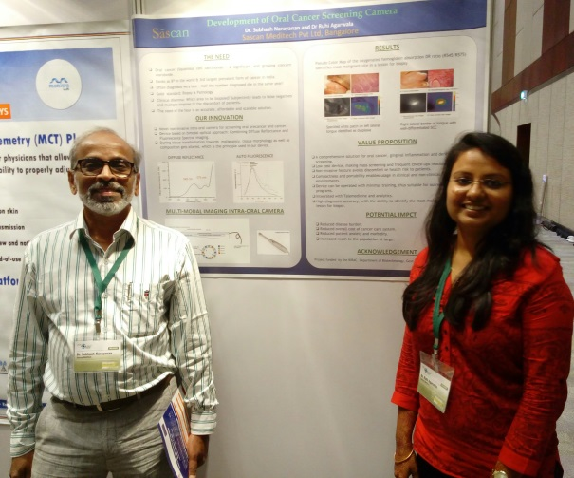 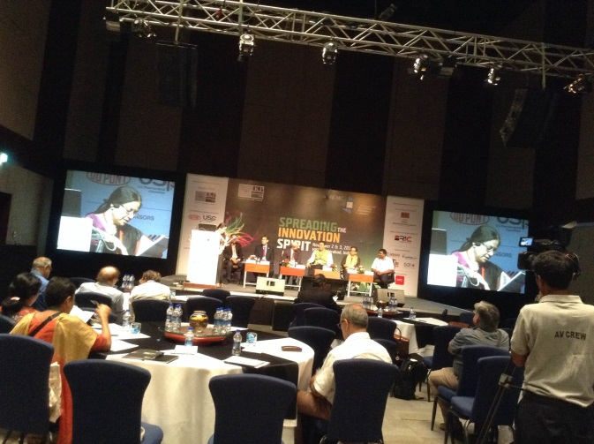

Sascan presented poster on 'Development of oral cancer screening camera' at IKMC 2015 Conference – Spreading the Innovation Spirit, during Nov 2-3 at HICC, Hyderabad. The International knowledge millennium conference, IKMC 2015 was a 2 day conference organized by Intellectual Knowledge Park, Hyderabad. It brought together innovators, startups, industry experts and policy makers to spread the spirit of innovation.

Home About Us Team Updates **Contact us**

SASCAN Early detection Saves lives!!

Contact us

We'd love to hear from you!

Sascan Meditech Pvt. Ltd.

Centre for Innovation in Biomedical Electronics

BMS College of Engineering, Bull Temple Road, Basavanagudi, Banaglore - 560 019, India

Phone: +91-9591345016

Email: [sascanmeditech@gmail.com](mailto:sascanmeditech@gmail.com)

(some of the sites we liked:

1. [www.bempu.com](http://www.bempu.com)
2. [www.Onebreathventilator.com](http://www.Onebreathventilator.com)
3. [www.ayzh.com](http://www.ayzh.com)
4. [www.embraceinnovations.com](http://www.embraceinnovations.com)

Design site for full view